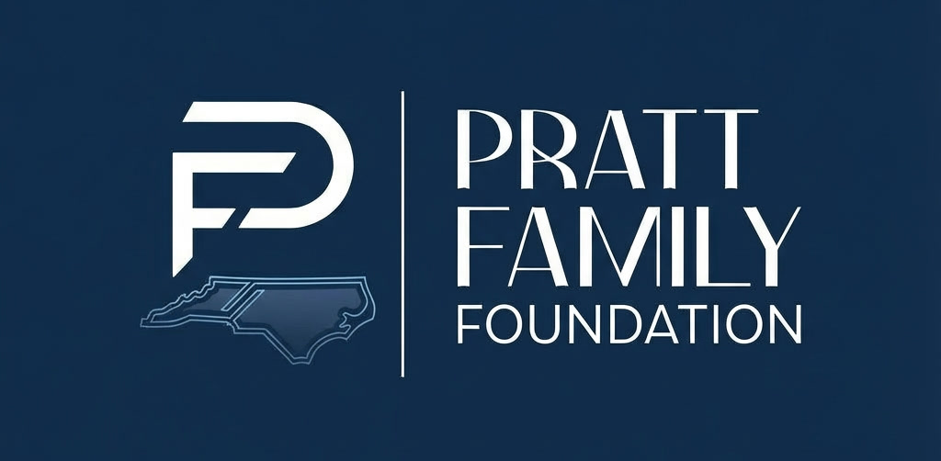

Funding Request

Please email this form to Elliot Berger with a copy of your latest tax return (unless it is publicly available online).

1. Organization Information

Today's Date
Organization Name
Executive Director
Primary Contact Person
Email
Phone
Address
Year received 501(c)(3) public charity status
# Board Members |  | # of Staff |  | #Volunteers

3. Project Description & Use of Funds

Initiative / Program Seeking Funding For
Amount Requested
Total Project Budget

Briefly describe project, proposed use of funds, timeline, and percentage allocated to operational costs.

4. Organization Category

☐ Disadvantaged Youth
☐ Healthcare / Women Facing Crisis Pregnancies
☐ Education (Scholarships / Schools / Summer Camps)
☐ Housing Solutions for At-Risk Populations
☐ Individuals with Special Needs
☐ Other (describe): ___________________________
5. Organization Mission & Impact

Describe the purpose of your organization and explain how programs are effective relative to similar charities.

4. Financial Overview

Current Annual Budget
Previous Year's Budget
Fundraising Costs as % of budget
Grants as % of total income
Fees as % of total income
Other as % total income

Total Financial Assets / Endowment
Total Reserves
Total Debt

Names of Other Key Funders: ______________________________________________________________________________________

6. Service Area

The Foundation primarily supports organizations serving Greensboro and the Piedmont region of North Carolina, while also supporting initiatives across the state.

Region # people serve
Greensboro / Triad / Piedmont Area
Other North Carolina Regions (include counties)

7. Comparable Organizations & Collaboration

Please list organizations providing similar programs and explain how your priorities are different from or complement one another. Note what lessons you have leveraged from them.

